**Conversation Guide: Digital Health Modernization Discovery Research**

**Bold text identify the moderator’s questions.**

*Text in italics are Emily’s observations and interpretations of the participant.*

[Text in brackets are interpretations in participants’ direct quote.]

**Background (5 minutes)**

To get started, I’d like to get a little background information about you, and your experience with the VA.

1. **Can you tell me a little bit about yourself?**

I was a Navy Corpsman and I live in NM. I work as a supervisor as a call center for medical clinics. And I work from home. Working from home as been good and I got promoted while all this stuff was going on, so that’s a plus.

1. **When did you leave the military?**

2000 June.

1. **What VA benefits do you receive?**

Just healthcare, I don’t have any percentage or that stuff.

**When you say percentage…**The disability percentage, whatever that’s called.

1. **Education or housing benefits?**

I have used my VA loan for a house, and I used all of my GI Bill.

**When did you use the GI Bill**: 2008 I used it all up.

*Participant seems to interpret these benefits as a one-time use. Is that the case?*

1. **Do you have any family members who you claim as dependents?** I have 1, they are 7 years old. Not claimed on VA healthcare.
2. **Do you manage any of your VA benefits online?** Yes

**Where do you do that?**  What is the…the portal, what ever that is called—My HealtheVet.

**Any other online tools?** I use pay.gov to pay for my prescriptions.

I did look up the apps, I guess they advertised some apps but they didn’t work like I thought they would, I took them off my phone.

**Do you remember which apps?** It was a while ago… I was excited to use them and they didn’t do what I thought they would do, so I have anymore patience for them.

VA launch pad, VARX refill. I think those are the two.

**Where did you see them?** I think I saw them on My HealtheVet.

**Do you remember what worked and didn’t:** I used them in the summer, the problem was… it just wasn’t opening the pages or something like that.

**Functionally it wasn’t working?** Yes.

**What did you want to use VA launch pad for:** It says to communicate with my care team but it was easier to go onto MHV.

It seemed like a third party app, it was just buffering and seemed like it was in testing phase or something like that.

**What about Rx refill:** the same, to refill what I needed and it did the same thing, just buffering.

1. **Do you use any mobile apps to manage your health?**  No.

**Mental model of health at the VA (20 minutes)**

Now I’d like to hear about your experience transitioning from the military to the VA. **(10 minutes)**

1. **How did you learn about the health care available to you through the VA, and what was the process of applying for and accessing those benefits?**

Originally when I started VA health care I was in San Antonio; I didn’t know the benefits were available for me because I didn’t have any disabilities or injuries or anything like that anything to claim. But I just went in the office and they pretty much just signed me up, it was a simple process. And I didn’t know it was available to me!

**What made you think this wasn’t available to you?** I worked in a military clinic for 8 years, and before that I was a contractor, and before that of course I was a Navy Corpsman, so I just figured that Veterans were people who had some kind of disability and claimed a percentage. I didn’t think that I was even considered anywhere in that party.

*Participant did not identify as the type of Veteran who needed VA benefits/services.*

So I went without… I was paying for health insurance from the time I got out to 2016. So that’s 16 years that I was paying for health insurance, because I didn’t even know that it was available to me.

**Which office:** Audie Murphy San Antonio

**How did you go:** It was just a walk in, and I pull a number and wait until my number was called.

**What motivated you to go that day?** I didn’t want to pay for insurance. I didn’t have a job at the time, so I didn’t have any insurance… It was a good surprise and I could have used it all along!

**Before you had VA insurance, did you have insurance through your job:** Yes I was a federal employee, so I did have benefits. Then I moved and left the job so I didn’t have any.

1. **Do you use any medical providers outside the VA for any of your health care needs?** No
2. **Dental or vision:** Yes for those I do. The VA here offers routine eye and glasses exams. Uses both Non-VA and VA for it.
3. **Difference between private and VA:** I don’t see much of a difference since I have been in the medical field both civilian and DoD I know how to get what I need and to navigate.

Does not use a separate portal or online tools for her non-VA health care.

1. **Since you first became a Veteran, has there been a change in the types of VA benefits you’ve received?**

I have only been using VA benefits since 2016, I haven’t seen much change. *Question was confusing – participant’s response is about the benefits themselves changing as opposed to applying for different benefits or needing new benefits other than health care.*

1. **You mentioned the GI Bill and home loan… do you remember when you used those?** used my VA loan in 2009 that was an easy process as well.
2. **What was it like:** The realtor took care of everything; I didn’t do anything.
3. **Online for VA loan:** No. *Participant laughs.*  It seemed like a lot to try and figure out for real estate.

Oh! I used HUD-VASH, housing assistance through the VA as well.

1. **Tell me about that:** That was in 2016, everything I have used has been really easy. They try to eliminate the stress with these things that we don’t tend to do on a daily basis.

It was refreshing to know that I had the benefits for me and I didn’t have to lift a finger really. I just had to show up and sign papers and everything was taken care of.

I didn’t appreciate that I didn’t know I had these things! I don’t know how these things are advertised; I wish my active duty station would have told me that these things are available to me. Going over a decade not knowing.

**Where did you go for housing assistance?** I know his name was Marcus, I don’t remember the office… it was in one of the VA clinics.

1. **How would you explain a “disability percentage” to a new Veteran?** *Moderator adopted the participant’s term “percentage” when talking about disability rating.*

Like a compensation of anything that was documented as far as medical visits, or any... I honestly think I probably qualify for something but because it’s been so many years, the paper trail, to try to track down… it just seems like a lot of work for me. So I haven’t gone. It just seems like an overwhelming amount of things that need to happen.

I would encourage someone who had just gotten out to get that fresh load of papers to the appropriate people versus… I’m quitting on that, so far. I won’t. I don’t have the time or energy to deal with that. I’m sure it would be beneficial though.

1. **If you had a change of heart, how would you start that process?**

I did start the process in San Antonio, they asked for all of my medical records. After that appointment, they said… see I don’t understand. They said they would track down the paperwork, but then I had to do it, too? That didn’t make sense to me.

When I was in [the Navy] it was all on paper and I am sure the providers I was seeing aren’t around anymore, so that paper trail isn’t fresh.

1. **In your mind, is there a relationship between “disability” and “health care”?**

Yes, I think there is a huge difference. It seems like a lot of people getting disability are probably not being truthful and milking the system. And probably lying just so… I dated a veteran recently and he would state he can’t walk or anything but outside of the VA he is doing all of that. So I think there’s probably a lot of undisclosed fraud going on.

I think health care across the board, I think there is a standard as what is to be followed. As far as health care goes, I think it is anyone that provides healthcare, I am sure there’s a standard of what is to be followed.

*Participant describes disability and health care with different philosophies, and places a particular judgement about truthfulness and fraud on the disability program.*

*How is this influenced by her perception of Veterans as “people with disabilities”—a group that she didn’t identify with, causing her to not pursue VA benefits when she first left the Navy?*

**If you had disability with the VA, do you think it would impact the health care you receive?**

No, I would think it is the same and I hope it is the same. No preferences, as far as ‘Oh, this one has this much percent, so let’s treat them differently as this one who has none,’ just ethically speaking.

1. **When it comes to your health care, what is the most important thing you need from the VA?**

Proper communication and timely communication.

For example it was a process in trying to get a refill. It is hard to get a response back. I try to stay on top of the turnaround time that is stated. And the staff that is retained, it seems like there are so many hands that go through employment and so, probably the ball gets dropped.

**Is the turnaround time something that’s requested of you?** No, the staff. If I were to request a refill there are so many days, there is like 48 hours or whatever the time frame is. I shouldn’t have to keep track of that. I would assume there are daily tasks that need to be routinely done.

**Feel like you need to check to ensure it is getting done?** Yes.

**How could we make that better?** I guess it would fall under the healthcare professional. Personal responsibility of getting their work done.

Now I’d like to ask you how you manage information and tasks related to your health care. For each one, talk me through the steps you’d take. If there is something that you go online to complete, I may ask you to share your screen so I can see what you would do. **(10 minutes)**

**Tasks** Moderator should prompt about device usage if participant mentions digital tools or resources.

* **How would you reach out to your VA care team if you had a question?**

The portal.

*Participant mentions she thought she had the URL saved. Types in* “myhealthvet.com” *although the results include the correct URL. Prescription refills is the 2nd result.*

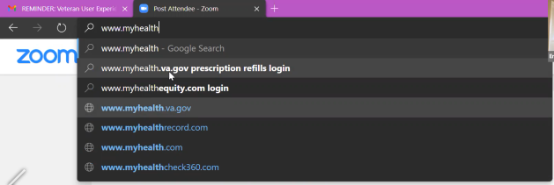



I thought I had it saved on here. I do everything on my phone, so.

**When you use your phone, how do you access the portal?** I have the link saved in a folder on my phone. I just click the link, it’s a shortcut I guess. And I have the passwords already saved in there.

*Participant logs in directly through MHV credential, not SSOe.*

*Participant has forgotten her password.* This is why I do it on my phone!

*Participant clicks on Messages from the MHV homepage.* I would click on messages.

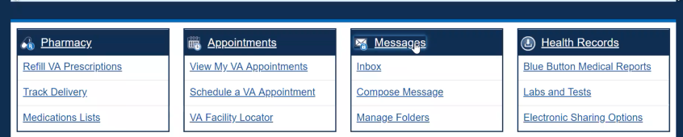 I Then I’d go to compose then find my clinic then go from there.



**Have you used this before, the messages?**  Oh, I use it all the time, whenever I need anything. Instead of being on hold for how many ever minutes.

* **How would you refill a prescription you have with the VA?**

Same way, I would click medication request and ask a question. *Participant is referring to the Subject: ‘Medication’ radio button in secure message.*

* **Similar to the messages, do you prefer to go through the portal as opposed to other methods like calling**? I try to avoid calling as much as possible. I just don’t have the time.
* **How would you check on an appointment you have with your VA care team?**

Through here, *participant laughs.*  I use it for everything VA related!

*Participant uses breadcrumbs to navigate back to homepage.*

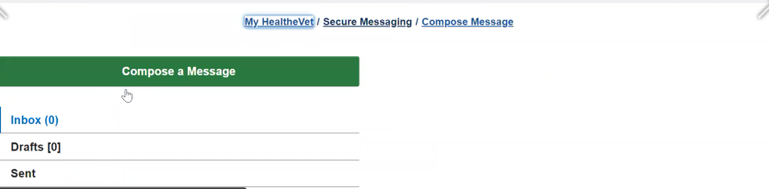

Just click view my appointments*. Participant refers to the ‘View My VA Appointments’ link under Appointments tile on homepage.*

* **An appointment for a provider (dentist, optometrist) outside the VA?**

I would have to call them.

* **How would you pay a VA health care bill, such as a copay?**

I logon to pay.gov. I just got a letter stating my prescription balance. *Confirmed this was a mailed paper letter, not email.*

*Participant navigates to pay.gov directly from browser; selects pay.gov from list below.*

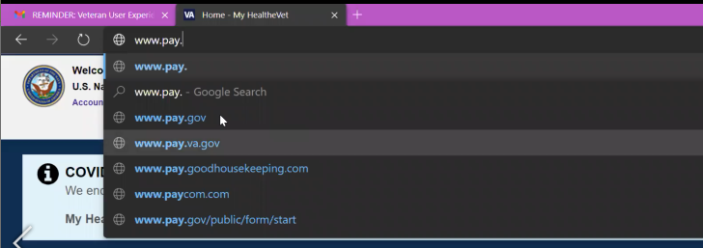

This is confusing because I would assume my balance would be on here but it never shows my balance. It just wants me to pay a balance I don’t know what it is, so I end up having to call or go off of my letters.

*Confirmed participant expects Pay.gov should tell her how much to pay.*

* **Can you walk me through the process of logging in?** Yes. I wish one would lead to the other. That would be easier. I don’t think there’s a link… I would think that they would be related. Maybe a link from My HealtheVet that would take me directly to here [pay.gov] and log me in?”

I don’t know what else pay.gov is for?

[30:22] **Other than the letter, how else would you know a bill you owe?** The only ways I would find out is if I were to call billing.

*Confirmed that pay.gov uses a separate credential from MHV.*

I don’t know if pay.gov takes care of government payroll or something, and that’s why they’re not related [not the same account]?

*Participant scrolls up and down the logged in homepage, looking for the right option.*

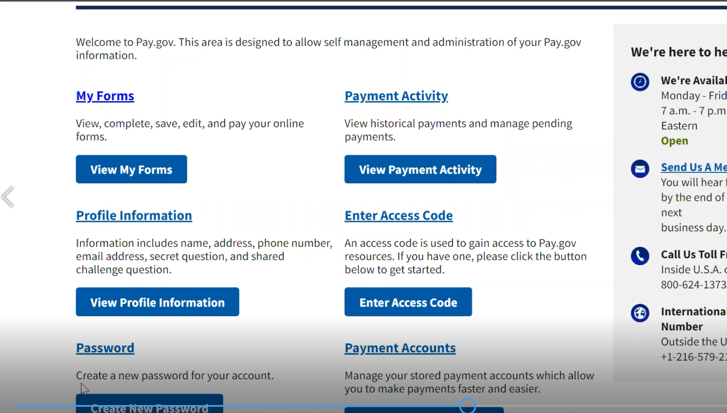

The only thing that would make sense is Payment Activity… maybe My Account? *Participant clicks* My Account *from the footer.*

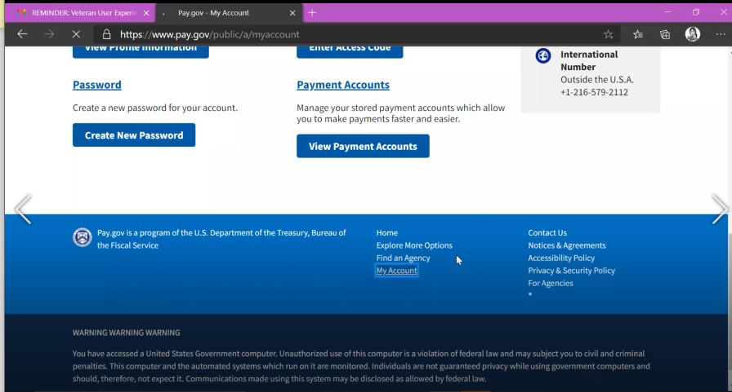

*Participant quickly leaves* My Account*, tries* Payment Activity*. When she doesn’t find what she is looking for, tries* Explore More Options *from the top navigation.*

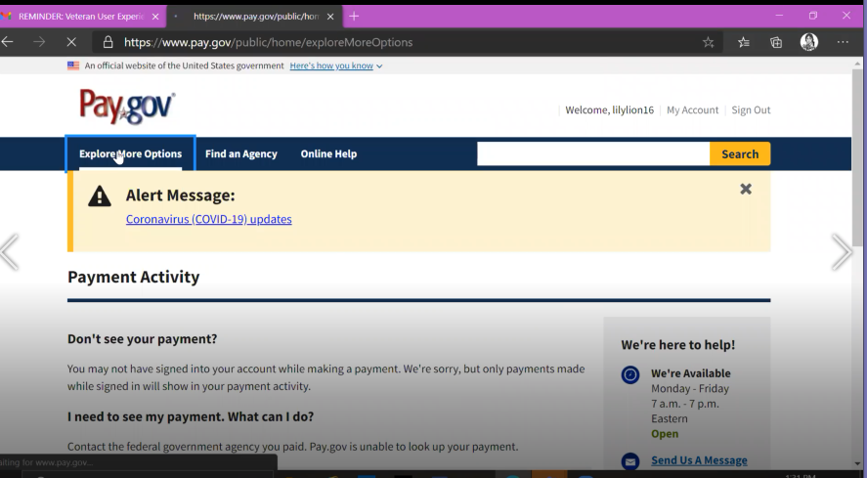

*Participant tries the first option she finds titled ‘Do you need to make your VA Medical copayment?*

**Does this seem like what you’re looking for?** Yes. I wish this was an easier process.

**Is this what you normally see when paying a bill?** I would think this would be preloaded because I already logged in with my credentials. I have to do this every single time. And it doesn’t tell me a balance at all.

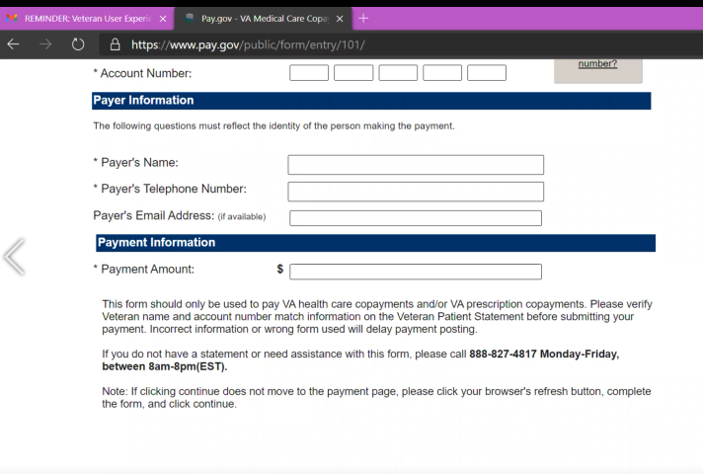

**You check the letter for that?** Yes. The account number—if I lost the letter I would be completely lost here. I would think this is preloaded.

**What is your process for this to ensure it doesn’t get lost?** I keep it on my desk and hope I don’t accidently throw it away.

**Any other feedback on this process?** I am looking at the letter now and I don’t see an account number here so I am kinda stuck. It says say pay online, by person, or on phone. It says [www.pay.gov](http://www.pay.gov), and it has my amount on this letter, but again, no account number. This doesn’t make any sense; I would have to call and who knows how long I would be on hold trying to take care of this.

**What number would you call?** There’s a number on the letter. Actually, there’s two numbers on this letter. One for questions/address changes then to make a payment call here…then there’s two more. So there’s 4 numbers on the paper.

**Which of the 4 would you choose?** I would use the one on how to pay.

* **How would you request reimbursement from the VA for traveling to your health care appointments?**

From what I remember there is a travel form to take to the travel department and take care of it like that.

*Confirmed she used to use this process in San Antonio VAMC.*

* **How would you add the dependents on your VA benefits?**

I guess I would take the birth certificate to the office and they would add them.

* **How would you make updates to your health care benefits?**

*Participant is confused by the question.*I am not sure what is changing, what would be changing?

**Branding and trust (5 minutes)**

Now I’d like to ask for your thoughts on My HealtheVet. (Confirm that participant has used My HealtheVet previously. If not, amend questions below to capture their first impressions while looking at a logged in account.)

1. **How would you describe My HealtheVet to a fellow Veteran?**

I would say it is user friendly, easy to use, everything is laid out and self-explanatory.

So the little blue blocks that categorizes pretty much every need that you would request from the VA. It is good how they have it laid out.

*Participant navigates back to MHV as we are talking.*

1. **What about “VA health care?”**

There is a lot of hurry up and waiting.

**Anything that seems to take a long time**? I can’t compare because I haven’t been in to the clinic here in Albuquerque but the one in San Antonio, there was a lot of waiting. I wanted to be choiced out because there not any availability in a primary care clinic at that hospital, and they didn’t get back with me for over a year.

As far as the care, I did work in the VA for 3 months and just getting patients in was a task because there were so many people trying to be seen.

And the wait times were—at scheduled appointments they were not seen in a timely manner. They were waiting hours for being seen at their scheduled time.

**Is that something you’ve experienced?** I had, but I don’t get seen a lot, I don’t have many health issues.

I try to schedule it first thing in the morning so there isn’t much wait or the last appointment in the day because they want to get out of there. Right after lunch… *Participant laughs.*

1. **On a scale from 1-5, with 1 being very dissatisfied, and 5 being very satisfied, how satisfied are you with My HealtheVet**? 5

**What makes you rate it a [their rating]? What would make it better?** Just the layout and the user friendliness. The design.

**Anything to make it better?** Just the link to pay.gov would be a big help. If it was linked, hopefully, the information would be preloaded for account information and name, all that stuff.

1. **On a scale from 1-5, with 1 being very low, and 5 being very high, how would you rate your trust in My HealtheVet?** I would say a 5 now but before everything was shut down and everyone had to go online [because of the pandemic], it didn’t seem like people were looking at it as much. Now they are forced to.

When everyone was going to in to clinic or pharmacies they were more concerned with people concerned with people showing up live rather than dealing with people on the computer. With everyone having to online it seems like it is running as it always should have. *Participant feels MHV is running better since the pandemic.*

**Have you personally felt a shift in how much you use it?** For myself no I have used it since day one, it’s just easier for me. The response time is better [since COVID.] Just responding back to messages.

**Do you feel the information is accurate and up to date?** Yes.

**How secure do you feel your information is in your account?** I am confident it is secure. I have no issues about that?

1. **If you have a question about your MHV account or something isn’t working, what do you do?** Go up here where it says Contact. Hopefully there’s some good information there. *Participant refers to Contact in header.*
2. **Have you ever been in touch with a My HealtheVet Coordinator?** No
3. **How does My HealtheVet compare with other online health tools you’ve used?** The only thing is the link to payments. The other places I’ve used is for my daughter. She uses a university medical system, it links up because it makes sense. If I had to make a payment, the information crosses over.

*Participant scrolls up and down MHV homepage.* I’m just looking to see if there’s a link to pay.gov…which I don’t see! *Participant sounds disappointed.*

Does your daughter’s health care have a similar portal? Her app is healthy life. I can get into it with figure print login. I use it for the portal… same thing I use it for myself. Prescriptions, messages, health record… *Confirmed this is a mobile app.*

**My HealtheVet patient portal (15 minutes)**

Let's take a look at My HealtheVet together.

Moderator will ask participant to share screen if not already, or show logged in My HealtheVet account. **(5 minutes)**

1. **What do you use this website for the most?**

I use it if I need to pull up previous labs, to see when I was seen last to make a follow up, send messages to the provider if I need anything.

1. **What do you find the most valuable on this website?**

The direct link to the providers is convenient. *Confirmed participant is referring to Secure Messaging.*

1. **What do you wish this website did that it doesn’t do right now?**

No.

1. **Outside of this website, are there other places you go to manage your VA health care?**

No.

1. **When it comes to your My HealtheVet account, can you think of a time when you needed to give access to a family member or someone else?** I never had to.

(If time allows) While we're here, I’d like to get your feedback on a couple of sections on this website. **(10 minutes)**

1. Get Care

* **Have you used any of the pages under "Get Care?"**  The treatment facilities. When I moved here, to see where the clinics are, how many clincis there are, if there are any branch clinics.

*Moderator prompts participant to click into Treatment Facilities.*

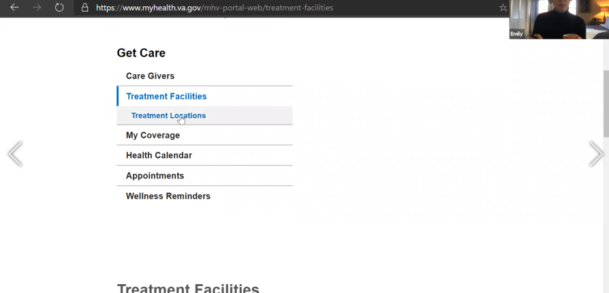

*Participant does not scroll down to bottom of page. When she doesn’t see anything above the fold here, she clicks on Treatment Locations. Treatment Locations shows a table of self-entered data; hers is empty. Participant uses breadcrumbs to navigate between Treatment Facilities and Treatment Locations.*

**Is that what you expected to see?** No, I thought it would let me enter a zipcode or something..

**What does it look like this showing you now?** What is this?? That’s misleading. I don’t see why I would I would use that then.

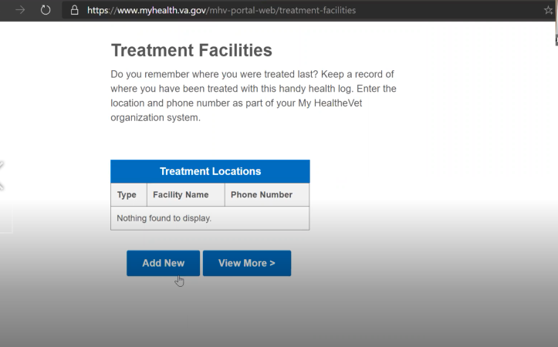

**Anything else that you would use under Get Care?** Appointments maybe? But its in the 4 blue blocks... maybe its just another way to get there? *Participant clicks on Appointments, scrolls down to the* VA Appointments Table*.*  Yeah, I guess just another way to get there?

1. Track Health

* **Have you used any of the pages under "Track Health?"** I only use the four blocks and I assume this takes me to the same place. *Participant refers to* Lab + *Tests link.*

**Thoughts under healthy living assessments?** I assume it is a lot of questions and advice that I probably already know. It is not available due to system issues. *Participant refreshes page*

**If it were the set of questions, would you use it:** No.

It is just tedious. I don’t think I did this. Oh look I did it…I don’t know why I did it I was probably bored.

It just feels like if whenever someone gets into something like this [health assessments] is just gonna tell you that you are not doing so great.

**Can you go back to the MHV from here?** *Participant clicks on VA Home from header.*

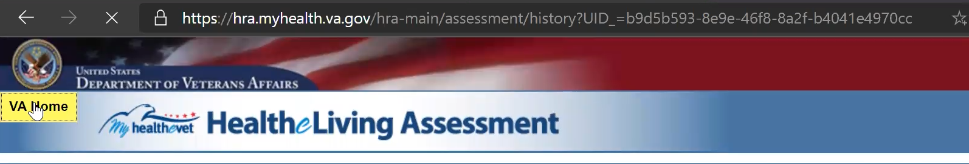

*Participant was redirected to VA.gov.* Why did it take me here? I just clicked back I was hoping it would take me back to where I was, but this looks like the main VA page.

Have you used it before: Not so much.

1. Research Health

* **Have you used any of the pages under "Research Health?"** No I haven’t used any of this.
* **Look under research health, impressions:** I wouldn’t feel the need to go into this at all. Unless it advertised financial compensation for research studies! *Participant laughs.*
* **What research do you think they are talking about?** Kind of like what you are doing with the studies.

1. MHV Community

* **Have you used any of the pages under "MHV Community**? This looks familiar, the mobile app.
* **Looking at these apps, did you try any of them other than VA Launchpad and Rx Refill:**  No I just picked ones that applied to me.
* **MHV newsletter, first impressions:** No, I would feel if I added my email I would get a lot of spam email.
* **Guess of what it would be about:** [reading page] Probably asking me to download the apps, I guess the general health things that come out weekly.